**MACHINE LEARNING IN FINANCE**

**LAB LOG BOOK**

**WEEK2**

Group by "relationship" and "hours-per-week".

Reduce all "hours-per-week" column values ​​in the original DataFrame by subtracting the value 'n'. Use a function.

Group ​​by "relationship" and reduced "hours-per-week".

**WEEK3**

## Draw a bicolour features interaction diagram.

Code:

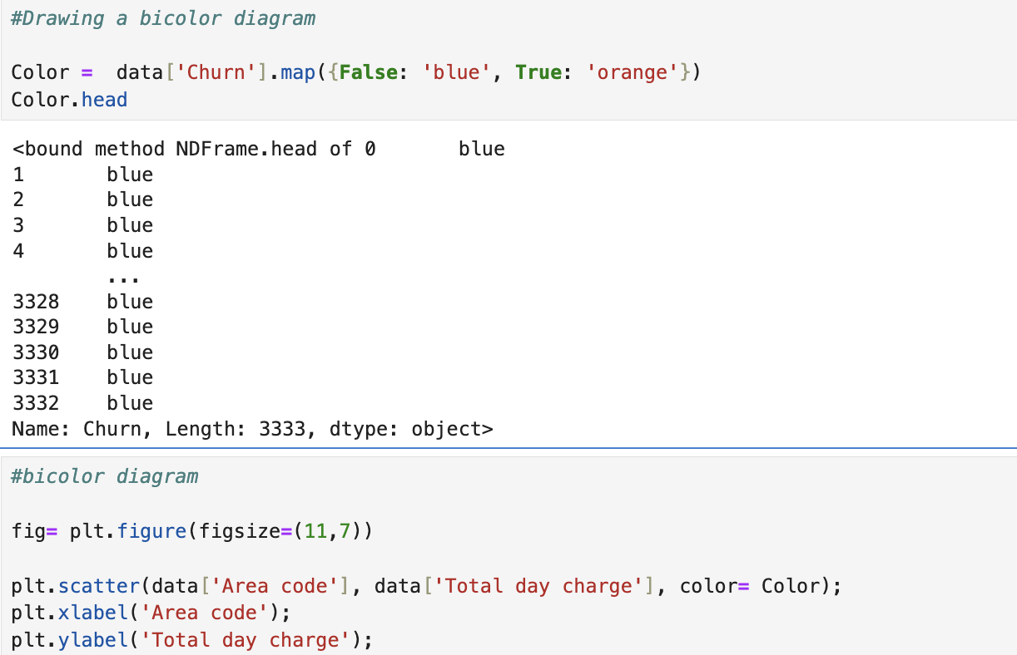

Output:

**WEEK4**

Code:

Output:

Compare your MAE with the MAE of the MLP in the practical session.

Code:

Output:

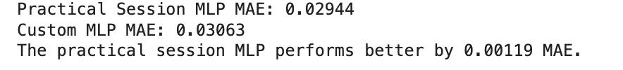

**WEEK7**

 LSTM architecture using model.summary()

the resulting test MSE & MAE

MAE detailed graph

**WEEK8**

**WEEK9**

**WEEK10**

**WEEK11**

**WEEK12**